Top of doc

Main game art inspiration: abiotic factor

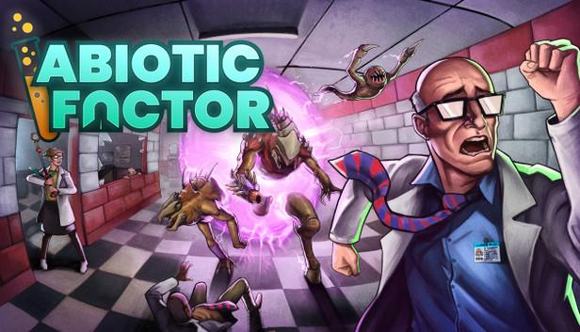

Art style is: realistic retro

From what i seen from the references the art style of abiotic factor is having realistic detail but also retro in terms of most the textures are pixelated and low quality.

The modeling process would be mostly simplified as most the detail decisions will be inside the textures. (image below)

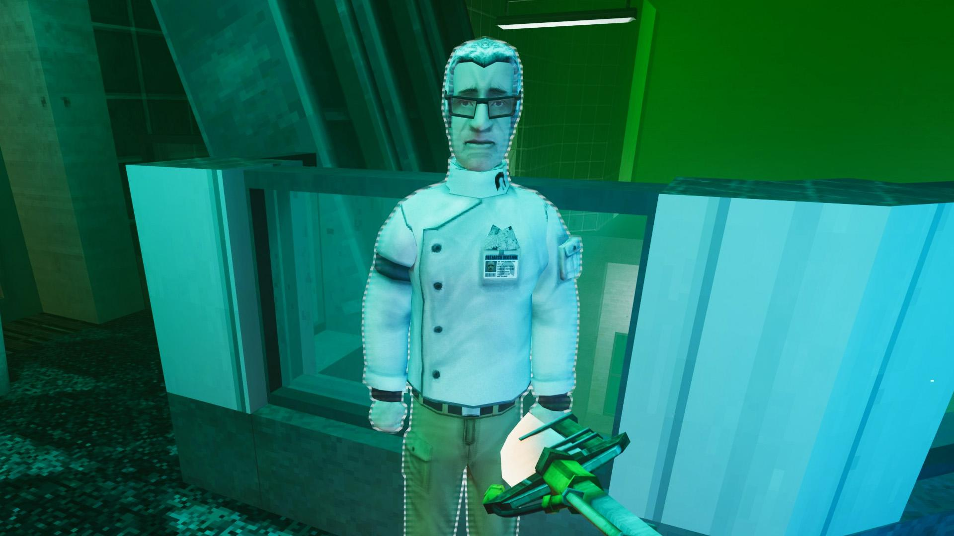

(image below): the quality of the textures are low but with great detail even flat surfaces have somewhat detail to give an old vibe.

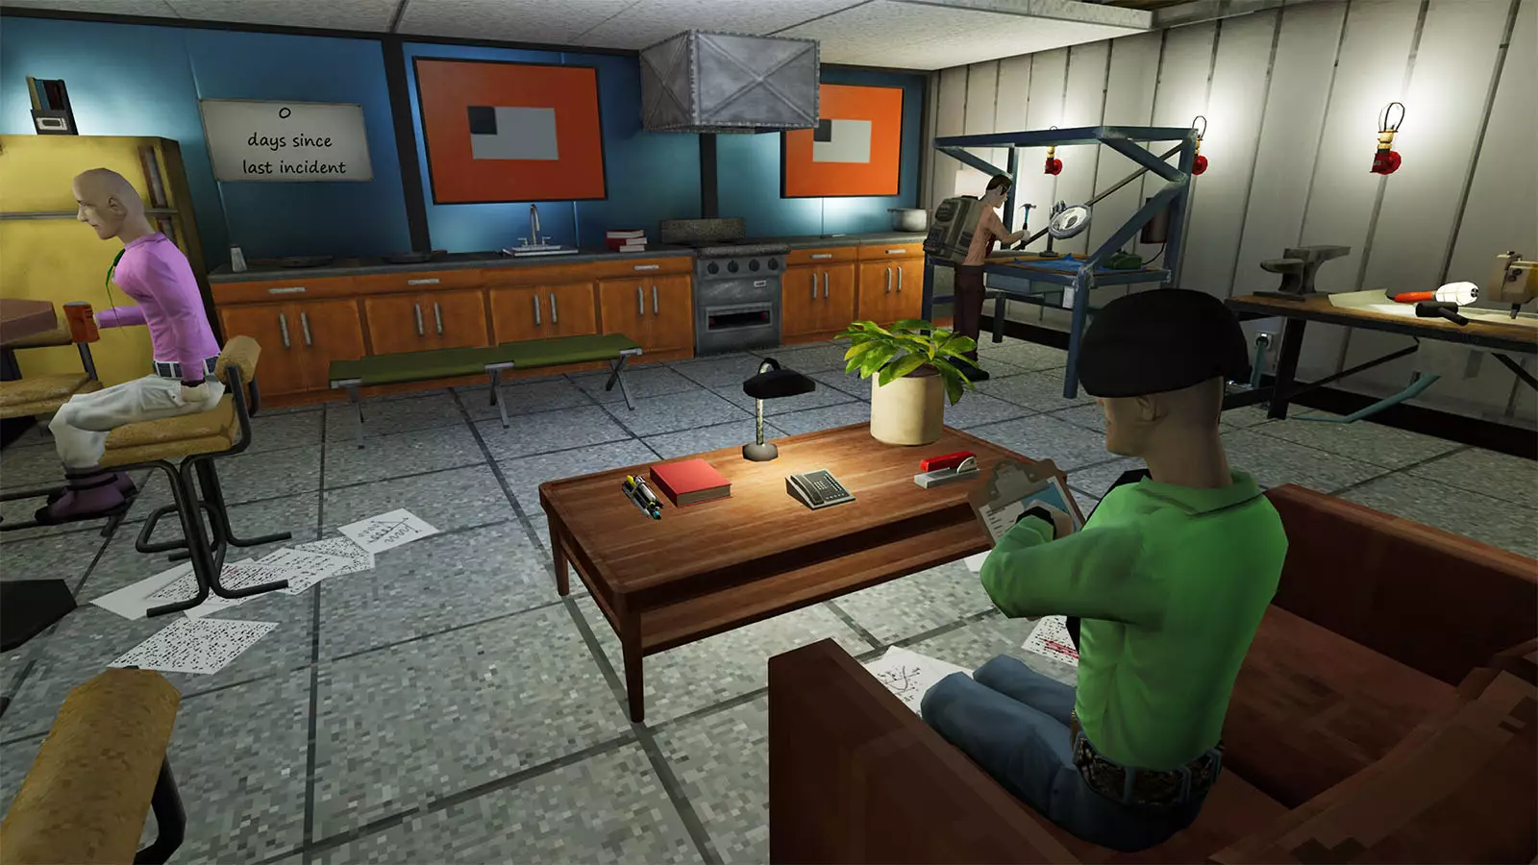

(Image below) one thing to easily notice is the character models are also similar to being simplified in detail. Such as the eyes and mouth are not modeled in. these details are in the textures. As the face features comes from mainly the detail on the textures and the shaping is subtle on the modeling part.

Hair doesn’t use alpha channels either. Their completely modeled then textures.



(image below)Alpha channels only been used on plants which all are a mix of being modeled and turn to an alpha channel (such as the tree is modeled in for the base and the branches are flat using alpha channels smaller plants don’t use this format their completely alpha channel flat like) as again the texture is stylized to look as retro like by being low quality textures with some realistic details in it. This go with alpha channels too.

(Image below): overall vibe is gritty and retro. The details are more in the textures, despite being a low quality format their in. the modeling it pretty simple. 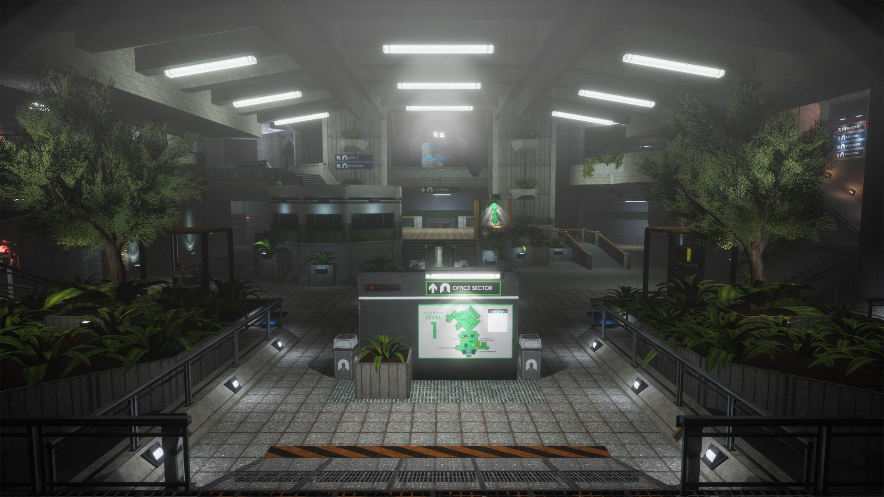

| Do’s | Don’t’s |
| --- | --- |
| * The details in modeling is simple like but not too simple. As i did in my flashlight. | * Most the details should be on the texture not model * The modeling isn’t too simple do not oversimplify the details in the modeling process. (abiotic factor doesn’t model their hands as just circles).   + Take note that in references of abiotic factor all hands are not model the same. It only better detail on the pov view side. (such as things the player is holding too).   + This what explains why the hands of the player model is detailed but the other models are simplified to being a merge fingers in a fist of a hand. Some hands also change depending on what their holding. |

(image examples below):

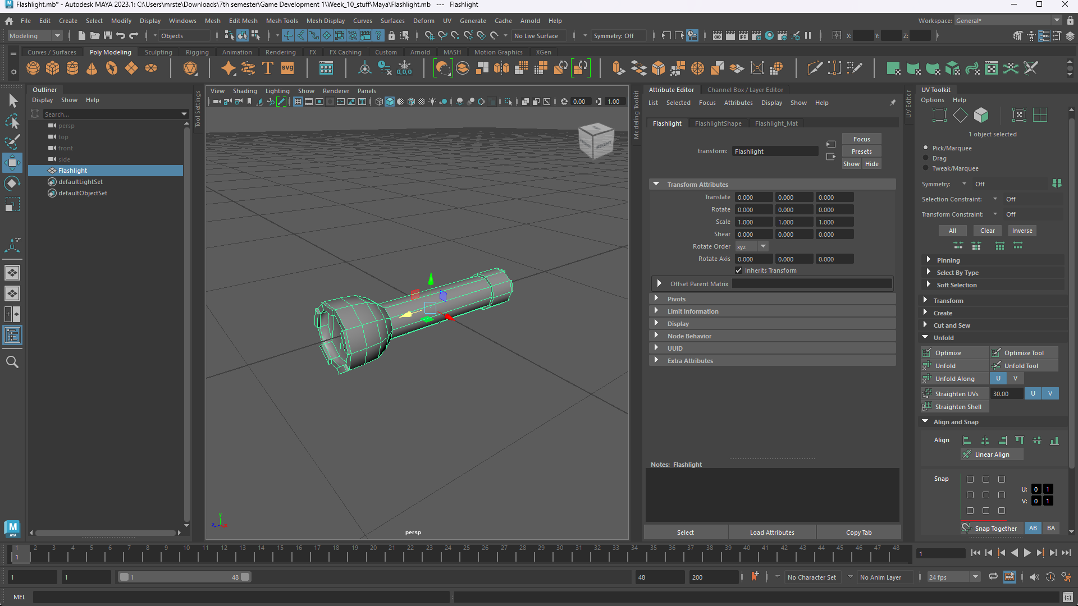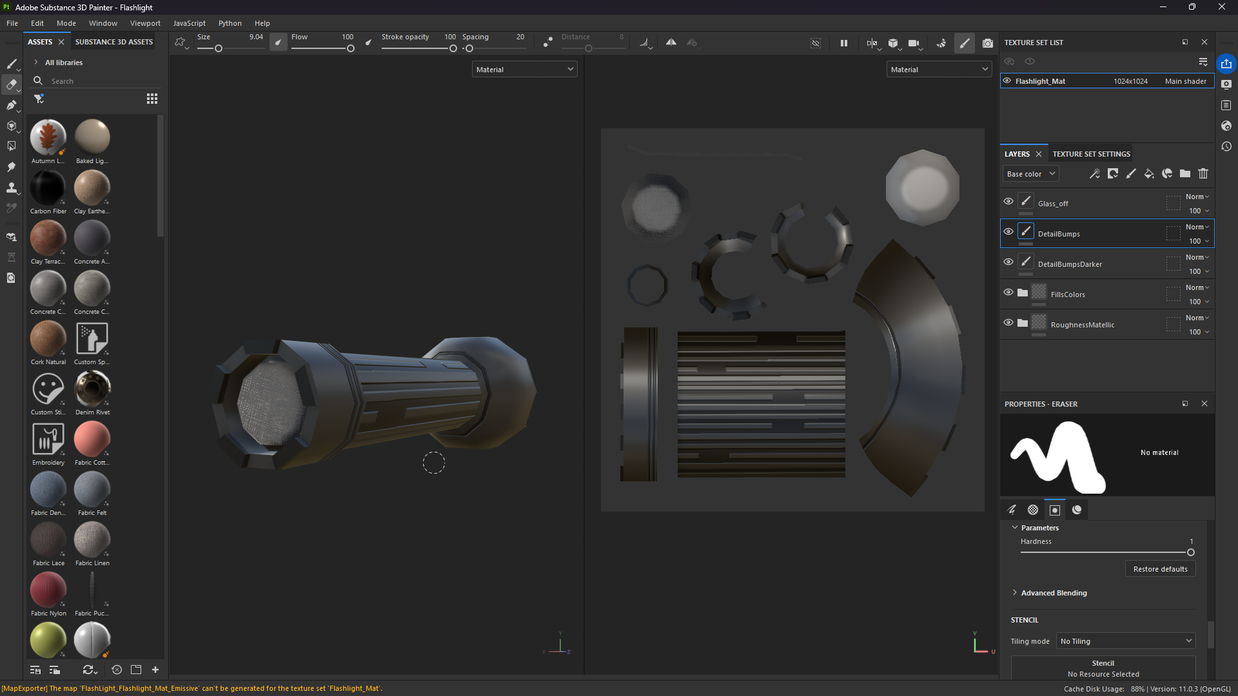

| Do’s | Don’t’s |
| --- | --- |
| * The texture quality shouldn’t be high. It retro like. I wouldn’t recommend texturing above 1k (1024x1024) * You can work with higher quality if you want(as I did with the flashlight above image) but make sure you lower the quality inside unity. As every texture should be easy to tell it is pixelated but has high detail. * Normal maps will be used for most the realistic details on the texture process aswell. Mak sure to lower the quality of the normal map textures aswell. | * Textures shouldn’t be in above 1024x1024(1k) * If you are working on high quality. Make sure the end result is still pixelated. * Do not put quality too low below 64 or where it is too pixlated. * Textures you don’t want to use, highly saturated colors for them to be a bit gritty. |

Bottom of doc